The Brave Beauty Series

Volume 2

Star of Persia

***A Story Adapted from the Book of Esther***

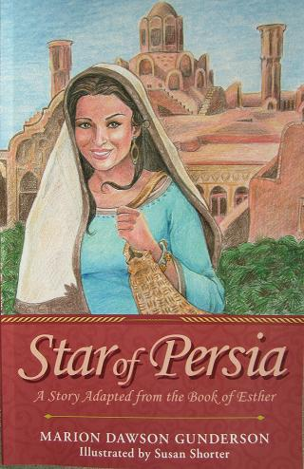

**MARION DAWSON GUNDERSON**

**Illustrated by Susan Shorter**

*Please Note:* Copyrighthttps://encrypted-tbn3.gstatic.com/images?q=tbn:ANd9GcSQZZ73zZZD2T29aRpGPg5AeIpggVokyXHD7LpSmoMyL1mUW0gi 2012 Marion Dawson Gunderson. All rights reserved. The reader may share or store this material, but may not modify it in any way.

ISBN: 978-1-4497-6065-6 *(sc)*

ISBN: 978-1-4497-6065-3 *(e)*

Library of Congress Control Number: 2012913151

1



A New Star

L

ong ago in the ancient kingdom of Persia, a beautiful baby girl was born. Her name was Esther, a word that means *star.* Esther quickly grew into a bright, happy little girl with dark shining eyes. Her hair was glossy chestnut brown streaked with golden highlights from the sun that blazed down upon Persia.

Esther’s favorite toy was a little cloth doll with black hair and purple eyes. Her name was Basha, a name that means *daughter of a promise*. Esther took Basha with her everywhere she went.

Esther spent most of her time in the family courtyard, playing with her cousins and her younger brothers, Gabe and Izzy. The children weren’t allowed to play in the street where slave traders could kidnap them.

Friday was Esther’s favorite day of the week because it was the start of the Sabbath, and Esther helped with the cooking. She loved doing grown-up jobs.

One Friday, Esther was perched on a stool at the kitchen table, working her fingers through some spongy bread dough. “Is this ready yet, Mama?” she asked.

“Yes Esther, you did a fine job,” said Mama with a smile. She lifted the dough from the table, formed it into a plump ball, and plopped it into a wooden bowl. “Now, please set this next to the oven to rise.”

Esther jumped down from the stool, slid the heavy bowl off the table, and placed it near the warm clay oven. Then she wiped her hands on her apron, picked up Basha, and sat on the floor. She began braiding tiny ribbons into Basha’s hair. “Mama, will we have grapes for the Sabbath?” she asked.

“Yes, purple grapes and Persian melons—and a special surprise for you!” Esther’s hands dropped to her lap.

“Pomegranates? Oh, Mama, please say pomegranates!” Esther set Basha in a basket and scrambled onto a stool. She peered anxiously about the kitchen.

Just then Gabe and Izzy sprang through the doorway. “Papa’s home!” shouted Gabe.

“He has gifts!” exclaimed Izzy.

Dashing back to the courtyard, the boys met their father with pleas of, “Please Papa, show us now!” Papa made his way into the house as Izzy grabbed at his father’s shoulder sack shouting, “Let me see! Let *me* see!”

“Calm down, you two!” smiled Papa striding toward the kitchen. “Let me greet your mother first.”

“Abe!” beamed Mama, “I’m glad you’re home early.” She hugged her husband, and noticed his bulging shoulder sack. “You must’ve had a good week at the shop!”

“Indeed,” replied Papa. “Since young Mordecai came to work for us, we’ve had a lot more time to keep the shelves stocked. “You know what we say—”

“Yes, dear, we know what you always say—”

Everyone chimed in, “If you don’t *have* it, you can’t *sell* it!”

“Now,” teased Papa, turning back to the children, “would this be a good time to open my sack?”

“Yes, open it *now!*” chorused the boys. Esther watched wide-eyed as her father slung his treasure sack to the floor.

“First, I thought we could add some *music* to our Sabbath,” said Papa, handing Gabe and Izzy small wooden flutes with a dancing camel design.

“Thank you, Papa,” said the boys. They began blowing on the flutes while trying to hum a tune. For Esther, there was a child-sized harp adorned with delicate gold tracings.

Oh, thank you, Papa!” cried Esther, “It’s beautiful!”

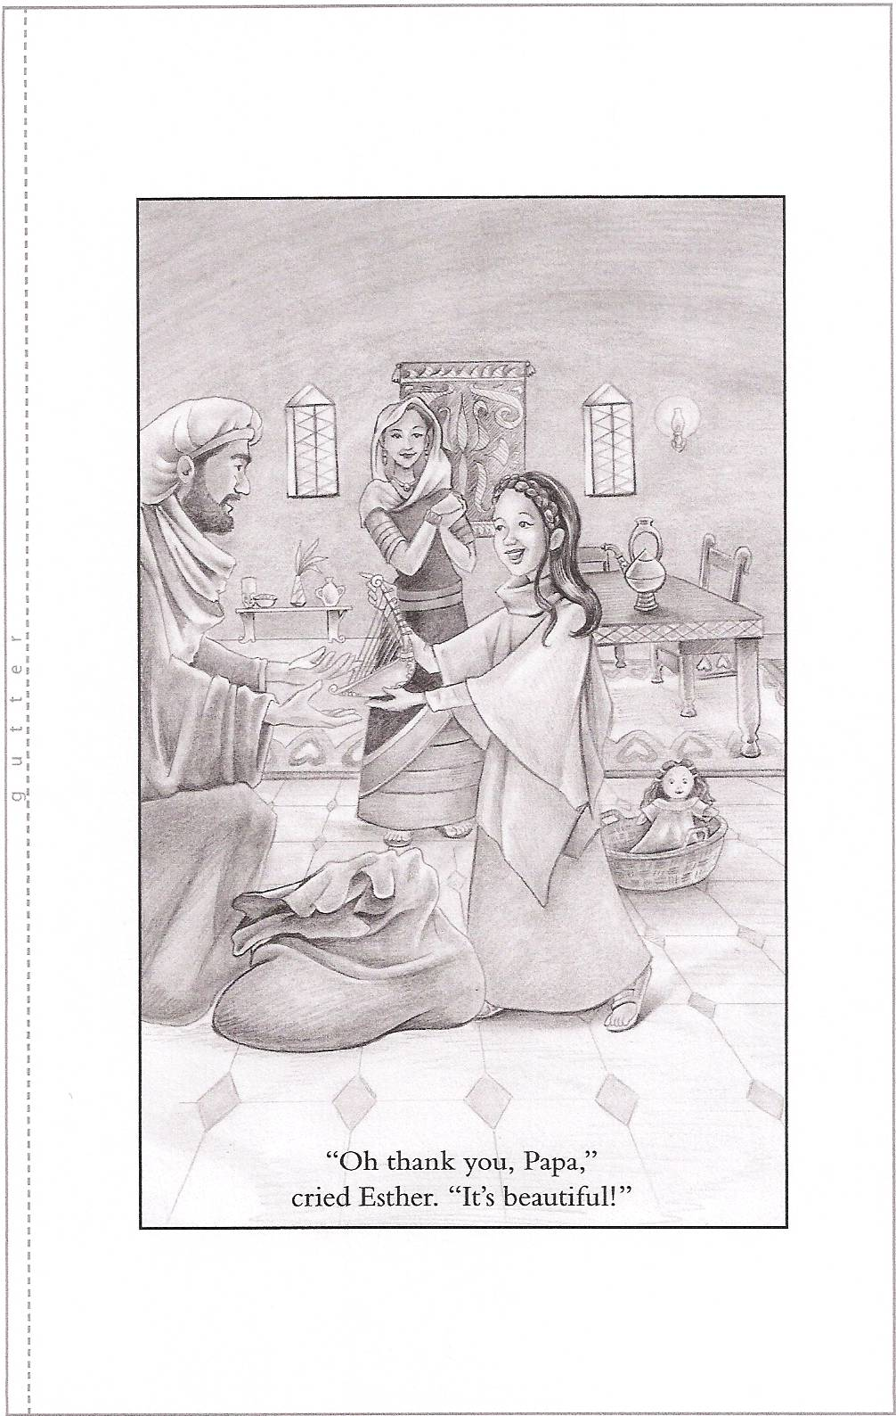Next, Papa pulled tiny horses and carts for Gabe and Izzy. The boys shouted in delight, and began racing the toys across the floor.

Grinning at Esther, Papa presented a doll-size table and two tiny chairs. “Papa, they’re perfect!” exclaimed Esther. “Thank you.” She picked up Basha and sat her on one of the chairs.

“Now here’s something for *all* of us,” announced Papa, displaying a wooden game board with animal playing pieces.

“I get the lions!” shouted Gabe, grabbing them up.

“Hah! I wanted the bulls anyway!” countered Izzy.”

“Boys!” scolded Mama. “Where are your manners?”

“Thank you, Papa,” said Gabe.

“Yes, thank you,” said Izzy.

“And now for my lovely wife,” said Papa. He presented Mama with a small olivewood jewelry box.

“Abe, what have you been up to?” said Mama, admiring the beautiful design on the box.

“It’s from the homeland,” said Papa. Esther watched her mother lift the lid.

“Oh my goodness!” gasped Mama. The box held a silver bracelet set with gold flowers. “It’s lovely!”

“So are you!” beamed Papa.

“Let me see it Mama!” cried Esther, dancing on tiptoes between her parents. She noticed a Hebrew inscription etched on the inside of the bracelet. “What does it say?”

“It’s from King Solomon’s poem,” explained Papa. “It says, ‘Your beauty shows as a flower among thorns!’”

“Oh, Abe, not *me*!” exclaimed Mama

“Yes, you! You’re still my beauty,” declared Papa. He ended the little ceremony by sliding the bracelet onto Mama’s wrist and kissing her on the cheek.

“Now I think that’s everything I brought,” said Papa. “Wait! There’s something else.” Gabe and Izzy jumped up from their game to see the final surprise. Holding up a net-like bag bulging with shiny red fruits Papa said, “For the Sabbath!”

“Pomegranates!” shouted Esther. “This is the best Sabbath ever!”

2

C:\Users\Marion\AppData\Local\Microsoft\Windows\Temporary Internet Files\Low\Content.IE5\HMJRV2ZC\MC900353812[1].WMF

The Blessing

T

he aroma of freshly baked bread filled the house. “Is it time to light the lamps yet?” asked Esther.

“Yes, the sun is at the rooftop,” said Mama, glancing across the courtyard. “Please call your brothers in.” Esther hurried to the doorway and yelled to Gabe and Izzy. They were having a miniature horse and cart race with some cousins.

Papa excused himself from a cluster of men in the courtyard and collected his sons. “It’s almost the Sabbath, you two,” said Papa. “Time to wash up.”

Mama was waiting at the door. “Please put your toys away,” she said.

“Aw, can’t we keep them?” whined Gabe. A stern look from Papa sent the boys scurrying to their room. When they returned, Mama steered them to the washbowl with clean towels. Esther set Basha in her basket just inside her bedroom.

While Papa added oil to the lamps, Esther and Mama set out salty green olives, syrupy figs, and five small goblets of pomegranate juice. Some of the pomegranates were served in slices so Gabe and Izzy could have fun plucking out the juicy seeds.

Mama lifted a steaming bowl of lentil stew from the oven and set it at Papa’s place. Finally, the fragrant bread arrived on a warm stone platter.

As the children took their places at the table, Mama lit the lamps, signaling the start of the Sabbath. The little room took on a soft glow. Mama sat down next to Papa. Everyone was quiet. Even Izzy’s wiggly body was lulled still by the mesmerizing flicker of the lamps. All eyes were on Papa as he stood at the head of the table.

Papa raised his hands heavenward. Mama and the children bowed their heads. “You are the one true God,” declared Papa. “We thank you for this day of rest. Our hearts praise you, O God of Israel. Thank you for loving us. Thank you for this family.”

Esther thought about her deep love for her family, though Gabe and Izzy could be annoying at times. *God has blessed us,* she thought.

Lowering his hands, Papa finished the prayer. “God our maker, we praise you for this food that you have brought forth from the earth. May it make us strong to serve you. Amen.”

*Now comes my favorite part,* thought Esther. *How will Papa bless us this time?*

Papa walked to where Gabe was sitting and placed his hands on the boy’s shoulders. “Gabriel, my eldest son,” said Papa, “may God give you the courage of Joshua.”

Moving to Izzy next, Papa prayed, “Israel my son, may God give you the obedience of Daniel.”

Then, placing his hands gently on Esther’s shoulders, Papa said, “Esther, my sweet daughter, may the God who blessed you with grace and beauty now bless you with—” Papa paused, his eyes closed as he searched for the words. “With the courage of Abigail.”

Papa returned to his chair. Mama began the meal by tearing off a piece of the warm bread and offering it to Papa.

*Abigail?* thought Esther. *Who is Abigail?*

3

C:\Users\Marion\AppData\Local\Microsoft\Windows\Temporary Internet Files\Low\Content.IE5\RMBDQLAN\MC900389602[1].WMF

The Peace Maker

T

he Sabbath morning began in the courtyard with the families gathered to hear the eldest men read the sacred books. Then everyone joined in the singing, with Esther softly strumming her new harp.

At noon, everyone enjoyed an outdoor feast of fresh bread, roasted vegetables, fruit, and stew that had been kept warm in ovens overnight. There were raisin cakes with thick cream for dessert.

As the afternoon sun rose higher, children played in little groups, women chatted under the trees, and men discussed plans for a larger synagogue where they could worship with other Hebrews from the city.

“Mama,” complained Esther, “Gabe is shooting seeds at us again.” Gabe ducked behind a tree, but Mama had already spotted him.

“Gabriel! You come here this instant!” ordered Mama. Gabe appeared from behind the tree and shuffled slowly toward her, his eyes downcast. Mama stretched out her hand, palm up. Gabe stared at it.

“What?” he asked.

“You know ‘what,’ Gabriel. Either give me that reed or you will stay inside today.” Gabe sighed, shrugged, and sauntered back to the tree. He picked up the hollow reed he’d used to shoot seeds, then returned and placed it in Mama’s hand.

“Perhaps God has given you a warrior’s heart,” said Mama, “but you mustn’t use it on your family!”

“Yes, Mama,” murmured Gabe. He turned and shot an angry glance at Esther, then disappeared into a group of boys engaged in a toy chariot battle.

“Thank you, Mama,” said Esther.

“It won’t happen again. Papa will talk to him.”

“Gabe kept the seeds from supper,” said Esther. “He hid them in his napkin.” Esther pointed to a red blotch on her Sabbath gown. “See? One of them left a stain.”

“I’m sorry, sweet one,” said Mama. “I’ll try to clean it tomorrow. We must not work on the Sabbath.”

Remembering Papa’s blessing, Esther asked, “Mama, who was Abigail?”

“Abigail?”

“From Papa’s blessing.”

“Oh, yes. That name surprised me too. Papa knows the holy books so well. Yes, I *do* remember the story of Abigail. She lived at the time of King David. She met David one day, before he was king.” Esther followed Mama to a shady bench. “Abigail’s husband was a rich man, but he was *very mean.”*

“Why did she marry him?”

“Women usually don’t get to choose their husbands”

“Will I get to choose *mine*, Mama? I want a husband just like Papa.”

“May God bless you with a good husband, my child. Now, let me finish the story. David helped Abigail’s husband a lot, but when David asked for some help in return, Abigail’s husband insulted him.”

“*Insulted?* What does that mean?”

“It’s when you say something—or do something—disrespectful to somebody.”

“What was the insult?”

“I can’t remember exactly, but in those days, when a man was insulted, it usually ended up in a fight. So David and his men got their swords and were going to kill Abigail’s people.”

“Including Abigail?” cried Esther, clutching Basha to her chest.

“I don’t remember, but they would at *least* have killed the men. So Abigail decided to stop it if she could.”

“How could *she* stop it?”

“She was a rich woman, so she decided to give David a big gift. It was her way of fighting evil with good.”

“What kind of gift?”

“Food. Lots of it. Abigail and her servants loaded up donkeys with bread, meat, raisin cakes, wine, cheese; the best food they had. Then they went out to meet David and his army.”

“She really *was* brave!”

“Yes she was. Now, when Abigail saw David coming with his men, she got off her donkey and bowed so low that her face almost touched the ground. She must have been shaking with fear, but she stood up and told David how sorry she was that her husband had insulted him. Then she showed David the food she’d brought him as a peace offering.”

What did David say?”

“He told Abigail she was a *wise woman!* He thanked her for the food, and promised not to fight with her husband. He praised God for Abigail.”

“Wow! So *that’s* why Papa blessed me with ‘the courage of Abigail.’”

“Yes, precious one. You may not need to save your family some day, but I can promise you there *will* come a time when you will need courage. It happens to everyone.”

“Thanks for telling me about Abigail, Mama.” said Esther. She gave her mother a quick hug, then skipped away to join her friends. *Gabe should apologize for shooting seeds at us,* she thought. *It was very insulting!*

To order a full length soft cover or e-Book of **Star of Persia** **hold down** **CTRL and click:** <http://www.bravebeautybooks.com/Bookstore.html>