Jewel of Canaan

A Story Based on the Book of Judges

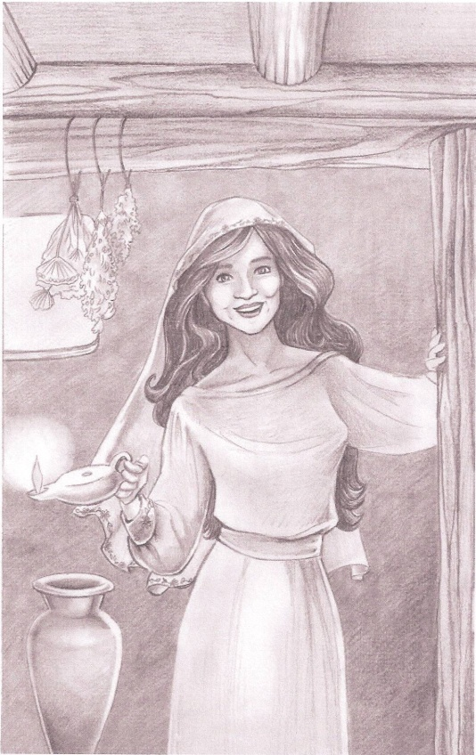

By Marion Dawson Gunderson

Illustrations by Susan Shorter

Please Note:

Copyrighthttps://encrypted-tbn3.gstatic.com/images?q=tbn:ANd9GcSQZZ73zZZD2T29aRpGPg5AeIpggVokyXHD7LpSmoMyL1mUW0giby 2012 Marion Dawson Gunderson

All rights reserved. You may share or store this material, but you may not modify it in any way.

ISBN: 978-1-4497-5202-6 (sc)

ISBN: 978-1-4497-5302-3 (e)

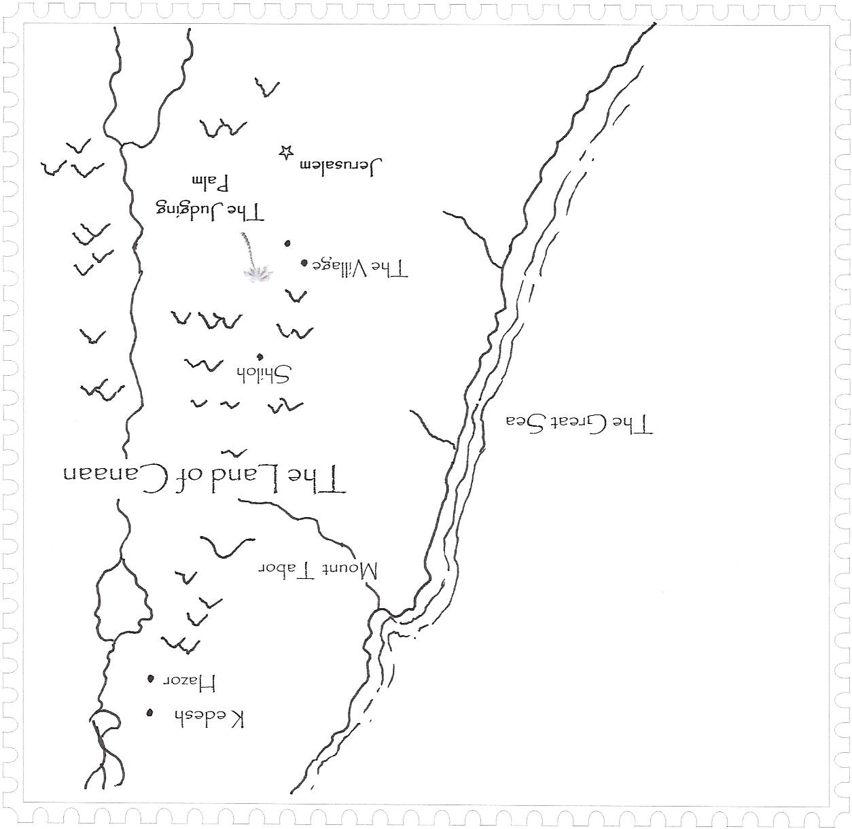

1

C:\Users\Marion\AppData\Local\Microsoft\Windows\Temporary Internet Files\Low\Content.IE5\NOVID6W1\MC900353875[1].WMF

Spring

L

ong ago in the land of Canaan, there lived a little girl called Deborah, a name that means bee. Deborah loved to play among the wildflowers that covered the hills near her village. She tagged along with her older brothers, Zev and Carmie, when they explored Canaan’s rocky cliffs and dark caves.

Deborah grew into a beautiful young woman. Her skin was radiant bronze from days spent in the sun. Shiny black hair framed her lovely face. Young men went out of their way to catch a glimpse of her when she worked at the weaving loom in the courtyard, or when she watched her twin sisters, Ariel and Alissa.

One morning, when Deborah and her mother were outside in the village courtyard,, Ariel and Alissa decided to make butter. They’d seen Deborah do it many times, and it looked like fun. Ariel took the bag of milk down from its peg in the kitchen, grabbed its leather strings, and began swinging it around like a windmill blade. Soon Alissa shouted, “That’s not how to do it! Let me!”

“No, it’s still my turn,” said Ariel.

“Let go! It’s mine!” demanded Alissa. She reached for the strings.

“No, you let go! I had it first,” cried Ariel. The twins pulled furiously, stretching the strings between them. Alissa yanked as hard as she could. The bag thudded to the floor, splashing the precious milk everywhere.

“Now see what you’ve done!” cried Ariel, shaking milk off her feet. “Wait until Mama sees this.”

Just then, Deborah appeared in the doorway with a jug of water balanced on her shoulder. Seeing the spill, she exclaimed, “What in the world—”

“It’s Alissa’s fault!” cried Ariel. “I had it first, and she—”

“It was my turn!” shouted Alissa.

“We’ll settle this later,” said Deborah, setting the heavy jug on the floor. “For now, you two need to clean up this mess.” She handed each girl a rag.

“But I—”

“No more arguing!” said Deborah. “After you’ve mopped up the milk, take some of this water and rinse it down. We don’t want this house smelling sour when Mama gets back.”

The twins sank to their knees, and began mopping silently. Deborah watched them with a stern expression that masked the deep affection she felt for her little sisters. “Let me know when you’re done,” she said quietly. “There’s one more thing we need to do.”



“Deborah, Alissa, Ariel, I’m home!” called Mama.

We’re out here, Mama,” called Deborah. Mama entered the kitchen, pausing to set some bundles of yarn on the table. She pushed open the door to the milking shed where her three daughters were crouched around a nervous she-goat.

“We’re having a milking lesson,” said Deborah. Ariel pulled and squeezed as the milk squirted into a clay jar.

“I got the most milk!” bragged Alissa.

“Did not,” countered Ariel. “I’m not done yet.”

“Stop boasting,” said Deborah. “You’ve both done very well. I’m proud of you.”

“I’m proud of all my girls,” beamed Mama.

“Alright girls,” said Deborah, “We’ve milked this goat dry.” She walked to a nearby wall and, using a small etching stone, scratched the days of the week into the chalky surface. Mama and the twins watched.

“Since you’re both good at milking,” began Deborah, “you’ll each have a milking day. Tomorrow will be Ariel’s day; the next day will be Alissa’s. Deborah wrote their names under their milking days.

“What about making butter?” asked Ariel.

“Today will be Alissa’s day to make butter.”

“But the milk got spilled!” blurted Alissa. She quickly cupped her hand over her mouth and looked at Mama.

“Oh?” said Mama.

“I’ll tell you about it later,” said Deborah. She turned to the twins. “Alissa will make the butter tomorrow. For now, you two go play in the courtyard. If you behave yourselves, I’ll teach you how to make flower crowns.”

“Yay!” chorused the twins as they scrambled out of the shed.

Deborah followed Mama back to the kitchen. “They were fighting over the milk bag and spilled the whole thing,” she said. “I made them clean it up.”

“They did a fine job,” said Mama. “I didn’t notice a thing.”

“I thought it was time they learned how much work it takes to get a bag of milk.”

“You were their age when you learned to milk. I can’t believe you’re already old enough to marry.”

“But Mama! I want to stay here and help you and Papa! You need me, don’t you?”

“I know you’ll always help us, sweet one, but we must think about your future. Papa will find a good husband for you. For now, we need to think about Zev’s wedding.” Deborah’s oldest brother, Zev, was engaged to a lovely girl named Miriam. They planned to be married in the fall. Mama pointed to the bundles of yarn. “I’m going to weave these into a sleeping mat for them.”

“The colors are perfect!” exclaimed Deborah. “I know they’ll love it Mama.” She started toward the back door. “I think I’ll see how the garden is doing.”As she stepped into the spring sunlight, Deborah thought, I wish I could choose my own husband!

*2*

**

*A Promise*

A

riel held up a chain of wild marigolds. “Is this good?”

“Very good, Ariel,” said Deborah. “It’s almost long enough.”

“Mine’s longer!’ boasted Alissa.

“This isn’t a contest,” said Deborah. “It’s better to do a good job than be the first one done.” The three sisters sat in a sunny field of wildflowers. Honeysuckle crept over the rocks, its sweet scent wafting through the late afternoon air. Birds twittered nearby as they gathered last year’s grasses for their nests.

“How long before we leave for Passover?” asked Ariel.

“Just three more days,” said Deborah.

“I get to ride the donkey first!” cried Alissa.

“Since you just put yourself ahead of your sister,” said Deborah, “you will be last to ride the donkey. You should put others first.” Alissa frowned and resumed weaving her flower chain.

“Deborah, why do we have Passover?” asked Ariel. “I hate it when they kill the lambs.”

“We do it to remind us that God freed our people from slavery in Egypt. That was more than two hundred years ago. Passover helps us remember.”

“I like the part about the plagues,” said Ariel. “Especially the frog plague, and the grasshopper plague, and—”

“And the plague of blood!” cried Alissa.

“The important thing is why God sent those terrible plagues,” said Deborah. “The pharaoh wanted to keep our people in Egypt to do all the work. It took ten plagues before he finally let them go!”

“I wish we could just remember it without killing the lambs,” said Ariel.

“I know,” said Deborah. “I hate that part too. But it helps us remember the tenth plague; the one with a promise.”

“What was the tenth plague?” asked Ariel. “I forgot.”

“It was the plague of the Death Angel,” said Deborah. “Our people put lambs’ blood on their door posts so the Death Angel would ‘pass over’ their houses and not kill anyone inside.”

Alissa looked up from her work. “You said it was the plague with a promise.”

“Yes. God promised to send his own Lamb for everybody. After that, we won’t have to kill our lambs anymore. God’s Lamb will pay for all the bad things we do.”

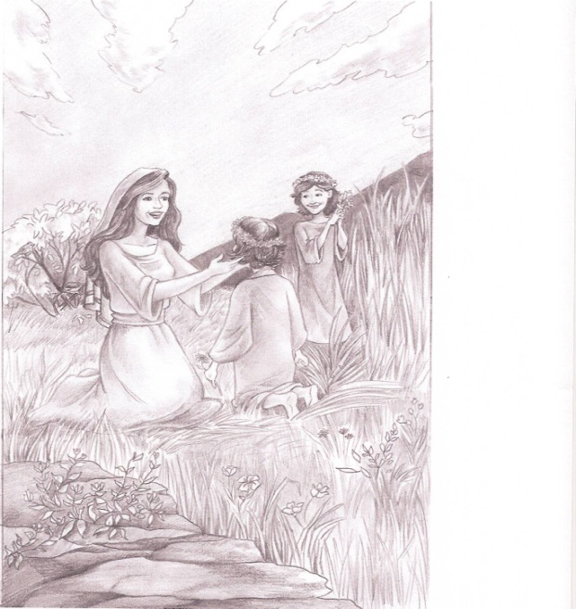“I just hope he sends his Lamb before Passover!” said Ariel.

Deborah tied the ends of the flower chains to form two rings, then placed them on the girls’ heads. “There,” she said. “Two princesses!”

The three sisters sprang to their feet and pranced about the meadow, stopping to gather flowers for Mama. Suddenly, they heard angry shouts in the distance. They stopped and peered in the direction of the sheep pen. Only Deborah could see over the tall grass. Two men strode toward the village. “It’s Zev and Carmie,” said Deborah. “Zev’s carrying something.”

The girls hurried down the hill toward home. When they arrived, only Mama was inside. Papa in the back by the garden talking to Zev and Carmie. He sounded angry. Carmie kept saying, “I’m sorry, Papa.”

Mama was kneading bread dough, her lips pinched tightly together. “What happened, Mama?’ asked Deborah.

“Carmie made a mistake,” said Mama without looking up.

“What kind of mistake?”

“Never mind.” Mama glanced at her daughters. “Papa will decide what to do. Now, I need the three of you to help with supper. Deborah, please shape this dough and set it outside by the oven.”

“Yes, Mama.”

“Alissa and Ariel, please wash your hands and set the table.” The twins hurried to the washbasin.

“And girls,” said Mama with a smile, “Your flower crowns are lovely.”



After a while, Zev and Carmie left the yard and headed back to the sheep pasture. Deborah noticed Zev carrying a lamb. Papa entered the house wearing a troubled look, and sank into his favorite chair without a word. Mama and the girls quietly busied themselves.

When supper was ready, Mama placed two bowls of lentil stew and a loaf of warm bread in a basket, then added a pouch of wine. “Deborah,” she said, “please take this to your brothers.”

“Yes, Mama,” said Deborah. She stepped outside, strode past the garden, and climbed the hill toward the pasture thinking, What could Carmie have done to make Papa so angry? When she arrived at the sheep pen, Zev and Carmie were herding the last of the flock in for the night. Zev was the oldest. He was known in the village for his skill in protecting the sheep. He’d never lost a single one to the lions, hyenas, and bears that roamed Canaan in those days.

Carmie hadn’t taken to shepherding. He had a soft heart for the animals. When one of them died, he grieved for days.

“Your supper has arrived!” announced Deborah with forced cheeriness.

“Just put it there,” said Zev flatly, pointing to a wooden stool near the pen.

Deborah set the basket down and approached Zev, who was locking the gate.

“I noticed you were carrying a lamb,” she said.

“Yes, I was,” said Zev.

“I hope it wasn’t injured,” offered Deborah.

“No, it wasn’t injured—exactly.”

“Oh? What happened to it—exactly?”

“It was spoiled!” Zev shot a searing glance at Carmie, who had settled onto a tree stump with his supper. Carmie stopped chewing and stared at his food.

“Spoiled?” prodded Deborah.

“Alright, I’ll tell you so you won’t keep asking about it. Carmie made a pet of our best lamb. He named it and talked to it like it was a baby. He didn’t want it killed for Passover, so he stained it with some dye he made from henna leaves.”

Deborah scanned the flock. She spotted a white lamb with red dye splashed across its fleece. Carmie looked up at Deborah, his face reddened with shame. “I’m sorry,” he said.

“I’m sorry too, Carmie,” said Deborah “What did Papa say?”

“He hasn’t decided my punishment yet.”

Zev and Carmie ate their supper in silence. Deborah sat near Carmie, patting him reassuringly. Finally, she gathered up the dishes and placed them in the basket. “Have a good night. See you in the morning.” She started toward the village, then turned back and called, “I love you both the same!” [end chapter 2]

To purchase soft cover or e-book version of **Jewel of Canaan,**

**Press CTRL** while clicking this link: <http://www.bravebeautybooks.com/Bookstore.html>